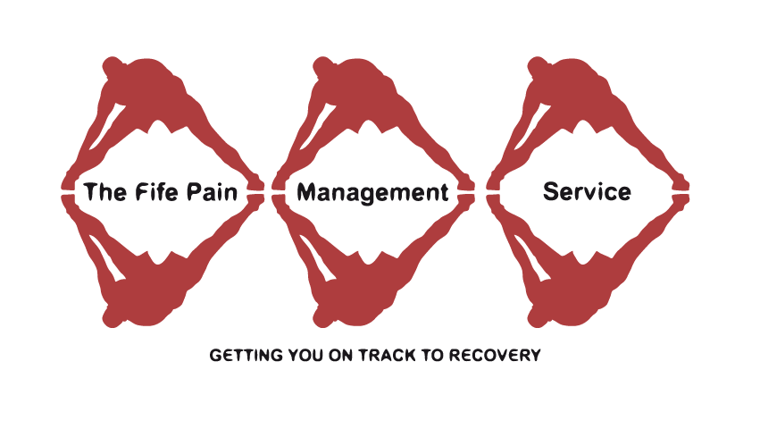
Daily Pain Diary

Completing a pain diary can be a very useful tool in helping you and the pain team understand how your pain levels are affected by your activities and medication.

Sometimes the diary can help you identify the things that make your pain worse and the things that help.

It would be extremely useful if you could complete 4-6 days of a diary and bring it with you for your first appointment with the pharmacist. Return in advance via post if virtual appointment.

Instructions:- an example sheet has been included

- At various times during the day, as often as possible, mark the line at the spot that reflects your pain levels at that time. The scale is from 0 to 10, with 0 representing “no pain” and 10 representing the “worst pain” possible.

- Record the activity that you were doing at the time (e.g. sitting, doing housework, sleeping, shopping, gardening etc).

- Record any pain medicine taken, at the time that you took it.

- At the bottom of the page record any general comments about your sleep/ feelings for the day

Don’t worry if you can’t complete 4-6 days- even a couple will be useful. Also don’t think you have to get up and record during the night- useful to do so if you are awake or complete retrospectively the next morning

Name: John Smith
Example sheet D.O.B: 23/1/45
Activity | Time | 0 | 1 | 2 | 3 | 4 | 5 | 6 | 7 | 8 | 9 | 10 | Medicine
No Pain Mild Moderate Severe Worst Pain
 | 8 a.m. | X |  |  |  |  |  |  |  |  |  |  | 2 cocodamol 30/500
 |  | X
Weekly shopping | 10 a.m. | X
Weekly shopping | 12 p.m. | X
Ironing | 2 p.m. | X |  |  |  |  |  |  |  |  |  |  | 1 ibuprofen 400mg
Watching TV | 4 p.m. | X
Making Dinner | 6 p.m. |  |  |  |  |  |  |  |  |  |  |  | 2 cocodamol 30/500
Watching TV | 8 p.m. | X  X
Reading before bed | 10 p.m. | X
 | 12 a.m.
 | 2 a.m.
Woken by pain | 4 a.m. | X |  |  |  |  |  |  |  |  |  |  | 2 cocodamol 30/500
 | 6 a.m.
Day and Date: Wed 3rd March
General Comments: Back really stiff and sore after walking around supermarket and putting all shopping away. Woken during night but pain killers helped

Name:

Activity | Time | 0 | 1 | 2 | 3 | 4 | 5 | 6 | 7 | 8 | 9 | 10 | Medicine
No Pain Mild Moderate Severe Worst Pain
 | 8 a.m.
 | 10 a.m.
 | 12 p.m.
 | 2 p.m.
 | 4 p.m.
 | 6 p.m.
 | 8 p.m.
 | 10 p.m.
 | 12 a.m.
 | 2 a.m.
 | 4 a.m.
 | 6 a.m.
Day and Date:______________ D.O.B:
General Comments:

Name:

Activity | Time | 0 | 1 | 2 | 3 | 4 | 5 | 6 | 7 | 8 | 9 | 10 | Medicine
No Pain Mild Moderate Severe Worst Pain
 | 8 a.m.
 | 10 a.m.
 | 12 p.m.
 | 2 p.m.
 | 4 p.m.
 | 6 p.m.
 | 8 p.m.
 | 10 p.m.
 | 12 a.m.
 | 2 a.m.
 | 4 a.m.
 | 6 a.m.
Day and Date:________________ D.O.B:
General Comments:

Name:

Activity | Time | 0 | 1 | 2 | 3 | 4 | 5 | 6 | 7 | 8 | 9 | 10 | Medicine
No Pain Mild Moderate Severe Worst Pain
 | 8 a.m.
 | 10 a.m.
 | 12 p.m.
 | 2 p.m.
 | 4 p.m.
 | 6 p.m.
 | 8 p.m.
 | 10 p.m.
 | 12 a.m.
 | 2 a.m.
 | 4 a.m.
 | 6 a.m.
Day and Date:__________________ D.O.B:
General Comments:

Name:

Activity | Time | 0 | 1 | 2 | 3 | 4 | 5 | 6 | 7 | 8 | 9 | 10 | Medicine
No Pain Mild Moderate Severe Worst Pain
 | 8 a.m.
 | 10 a.m.
 | 12 p.m.
 | 2 p.m.
 | 4 p.m.
 | 6 p.m.
 | 8 p.m.
 | 10 p.m.
 | 12 a.m.
 | 2 a.m.
 | 4 a.m.
 | 6 a.m.
Day and Date:__________________ D.O.B:
General Comments:

Name:

Activity | Time | 0 | 1 | 2 | 3 | 4 | 5 | 6 | 7 | 8 | 9 | 10 | Medicine
No Pain Mild Moderate Severe Worst Pain
 | 8 a.m.
 | 10 a.m.
 | 12 p.m.
 | 2 p.m.
 | 4 p.m.
 | 6 p.m.
 | 8 p.m.
 | 10 p.m.
 | 12 a.m.
 | 2 a.m.
 | 4 a.m.
 | 6 a.m.
Day and Date:________________ D.O.B.
General Comments:

Name:

Activity | Time | 0 | 1 | 2 | 3 | 4 | 5 | 6 | 7 | 8 | 9 | 10 | Medicine
No Pain Mild Moderate Severe Worst Pain
 | 8 a.m.
 | 10 a.m.
 | 12 p.m.
 | 2 p.m.
 | 4 p.m.
 | 6 p.m.
 | 8 p.m.
 | 10 p.m.
 | 12 a.m.
 | 2 a.m.
 | 4 a.m.
 | 6 a.m.
Day and Date:__________________ D.O.B:
General Comments:

